

High Level Design (HLD)

Entertainer Data Analysis

Revision Number: 1.0

Last date of revision: 14/02/2023

Abhijeet Sethy

Sandeep Kumar Sahoo



High Level Design (HLD)

**Document Version Control:**

|  |  |  |  |
| --- | --- | --- | --- |
| **Date Issued** | **Version** | **Description** | **Author** |
| **14th February 2023** | 1.0 | First Version of Complete HLD | Abhijeet Sethy  Sandeep Kumar Sahoo |

[AUTHOR NAME]



High Level Design (HLD)

**Contents**

**Abstract**..............................................................................................................................4

1 **Introduction**…….…………………….................................................................................5

1.1 Why this High-Level Design Document?.........................................................................5 1.2 Scope ................................................................................................................................5

2 **General Description** ...........................................................................................................6 2.1 Product Perspective & Problem Statement .......................................................................6

2.2 Tools used.........................................................................................................................6 3 **Design Details**.....................................................................................................................7 3.1 Functional Architecture ....................................................................................................7 3.2 Optimization .....................................................................................................................7 4 **KPIs**.....................................................................................................................................8 4.1 KPIs (Key Performance Indicators) .................................................................................8 **Deployment**............................................................................................................................9



High Level Design (HLD)

**Abstract**

People need to unwind because daily living can be stressful. A great method to pass the time in life is to be amused by others. It can ease tension and make dealing with problems in life simpler. The film, television, radio, and print industries make up the media and entertainment sector.

Movies, TV shows, radio shows, news, music, newspapers, magazines, and books are among these categories. The entertainment industry is a collection of related sectors. The term "entertainment industry" refers to the media corporations that oversee the production and distribution of mass media entertainment.

High Level Design (HLD)

**1 Introduction**

**1.1 Why this High-Level Design Document?**

The purpose of this High-Level Design (HLD) Document is to add the necessary detail to the current project description to represent a suitable model. This document is also intended to help detect contradictions prior to coding, and can be used as a reference manual for how the modules interact at a high level.

**1.2 Scope**

The primary goal of the study was to identify the top entertainers based on the amount of nominations and awards they have received over their careers so far.

High Level Design (HLD) 

**2 General Description**

**2.1 Product Perspective & Problem Statement**

This project will provide us a quick overview of the career paths of entertainers up to this point; information such as how many nominations they have received or how many awards they have won. Additionally, names of accolades like the Grammy, Oscar, and Emmy were listed here along with a few others.

The year of first award of each entertainer is mentioned in the dataset which gives us an insight about the time when they were first recognized for their talent.

The objective of the project is to perform data visualization techniques to understand the insight of the data. In this project we used Microsoft Power BI to get a visual understanding of the data.

* 1. **Tools used**

Business Intelligence tools such as Excel, Power BI are used to build the whole framework.

* The data was first cleaned in Excel based on univariate analysis for each number column.
* Using MS Excel, the data is cleaned, unwanted columns and outliers are removed, and individual award columns are created for improved visualisation. For the purpose of visualisation, a new column was created with the appropriate image URL. Power BI is used to build interactive visuals, Dashboards with data sourced from Excel.





High Level Design (HLD) 

**3 Design Details**

**3.1 Functional Architecture**

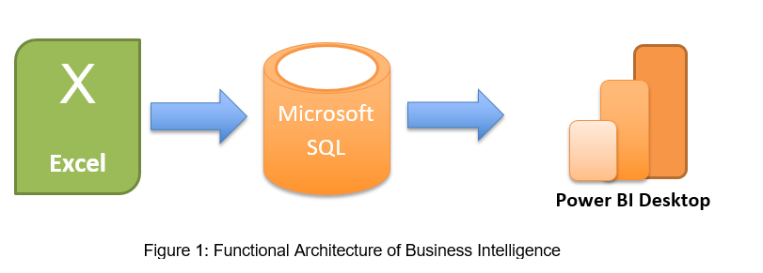



First the raw data which was given by the client in .CSV format was uploaded in Excel and done brainstorming session to understand the data. There are some unwanted columns which was deleted. Then efforts are made to clean the raw data and remove outliers. Several columns were added like Individual columns for different awards and Entertainers Photos were also added for better understanding.

**3.2 Optimization**

**Your data strategy drives performance**

* Optimize extracts to speed up future queries by materializing calculations, removing columns and the use of accelerated views

**Optimize and materialize your calculations:** Additionally, a category for the awards was formed, and charts were made to show the top performers. The information for Entertainers was obtained directly from the IMDB website. Filters are utilised to only take the top 10 entertainers into consideration when the number of entertainers increases.

[AUTHOR NA

High Level Design (HLD) 

**4 KPIs**

Dashboards will be implemented to display and indicate certain KPIs and relevant indicators for the Entertainer Analytics. As and when, the system starts to capture the historical/periodic data for a user, the dashboards will be included to display charts over time with progress on various indicators or factors.

**4.1 KPIs (Key Performance Indicators)**

In this project key indicators displaying a summary of the response and its relationship with different metrics

1. Total Nominees
2. Total Awards
3. Most Oscars
4. Most Emmies
5. Most Grammies
6. Other Awards

]

High Level Design (HLD) 

**5 Deployment**

The final report is published in Power BI service. Then the link is shared to client. Below is the document link to access the report.

**Link: https://app.powerbi.com/view?r=eyJrIjoiYzkxNzc5NTItNmM2OC00MWRhLWExYWEtZGY1ZGMzNjAyMTc4IiwidCI6IjFlODI2NjA0LWQ0Y2QtNGUyYi04MWQ1LWVkYzRjZDJiYjFiOSJ9**

Also the entire project is uploaded in Novypro.com for public use.

**Link**: **https://www.novypro.com/project/pbix**

[